Sharify User’s Guide

The following is a user’s manual for Sharify, our music sharing application. The mechanic of the application should be fairly straight forward, but we tried to outline how to accomplish the majority of the functions that a user would typical perform.

Table of Contents

* **Logging in**
* **Starting a Stream**
* **Managing Your Stream**
* **Joining a Stream**
* **Managing the Queue**
* **Playing/Pausing Music**
* **Adjusting Volume**
* **Viewing User Profile**

**Logging in**

The login page looks like this. You must login to the site using a Spotify account.



When you click the Log in with Spotify button, you get forwarded to Spotify’s website to complete the authentication process.

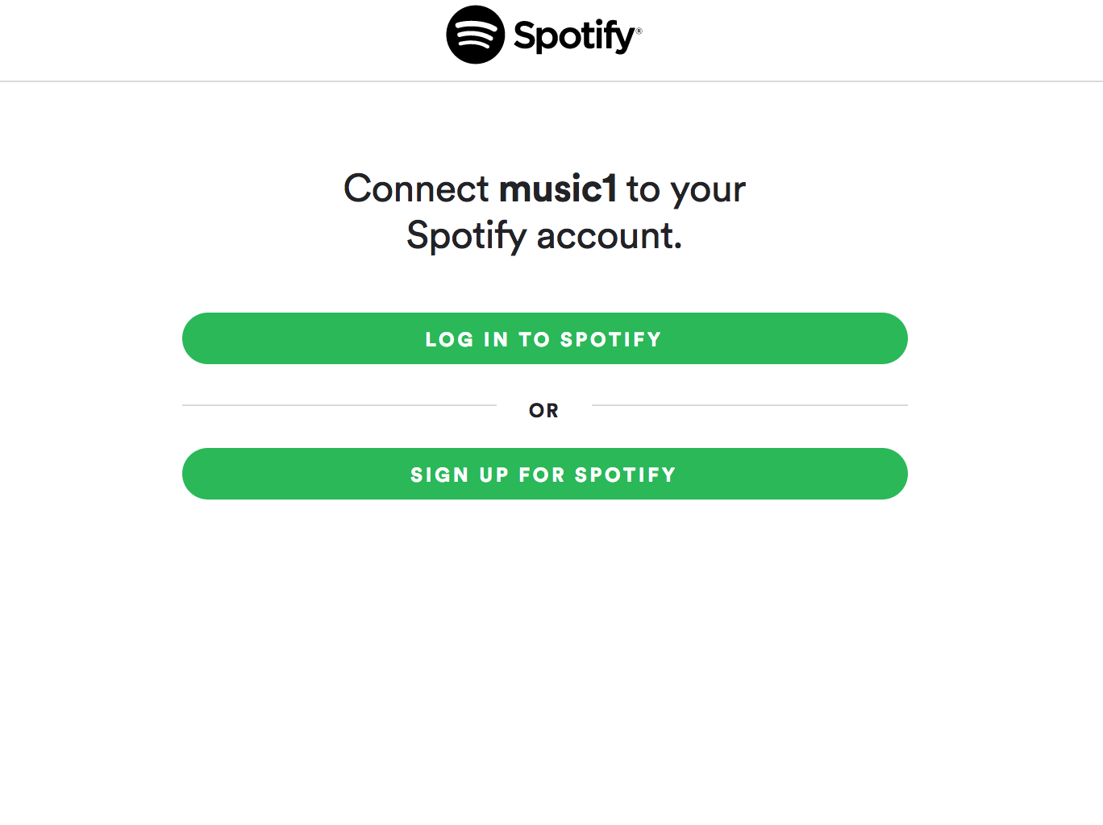

**Starting a Stream**

To start a stream, click the start stream button.

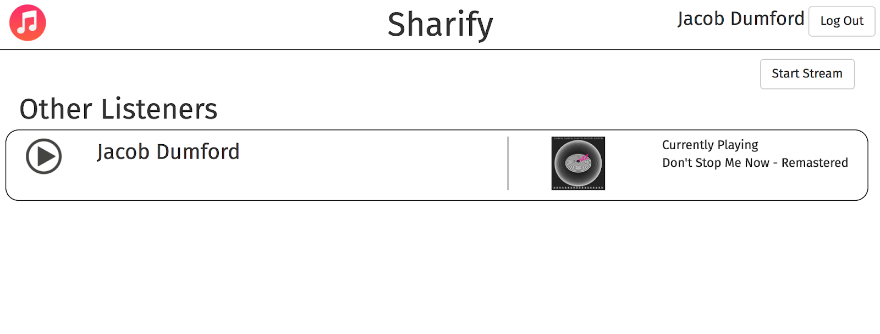

A form window will pop up. Enter a description and select your privacy settings. Then click the start stream button and you will be live!

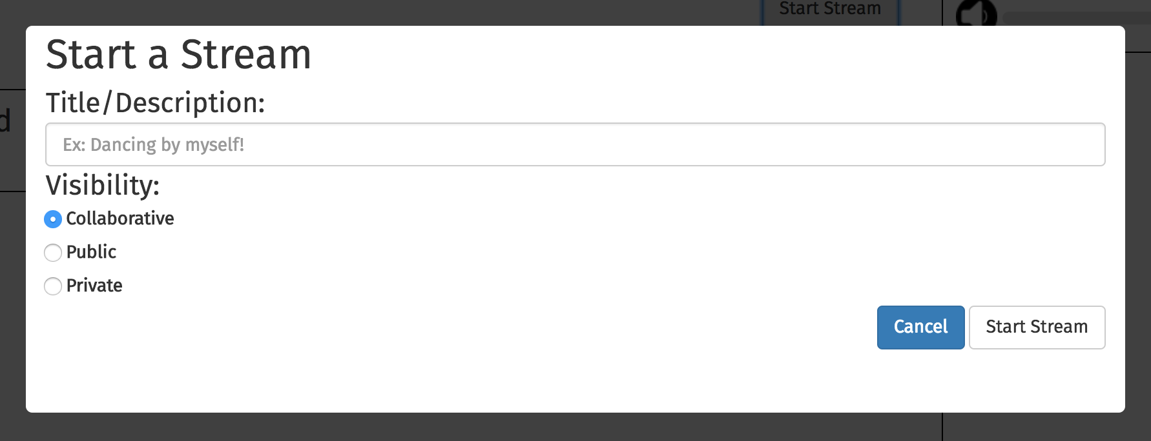

**Managing Your Stream**

To find music to add to your stream, there are two options.

1. Import songs from your Spotify playlists: All your public Spotify playlists will be visible in the select playlist tab within the Manage Playlist section.

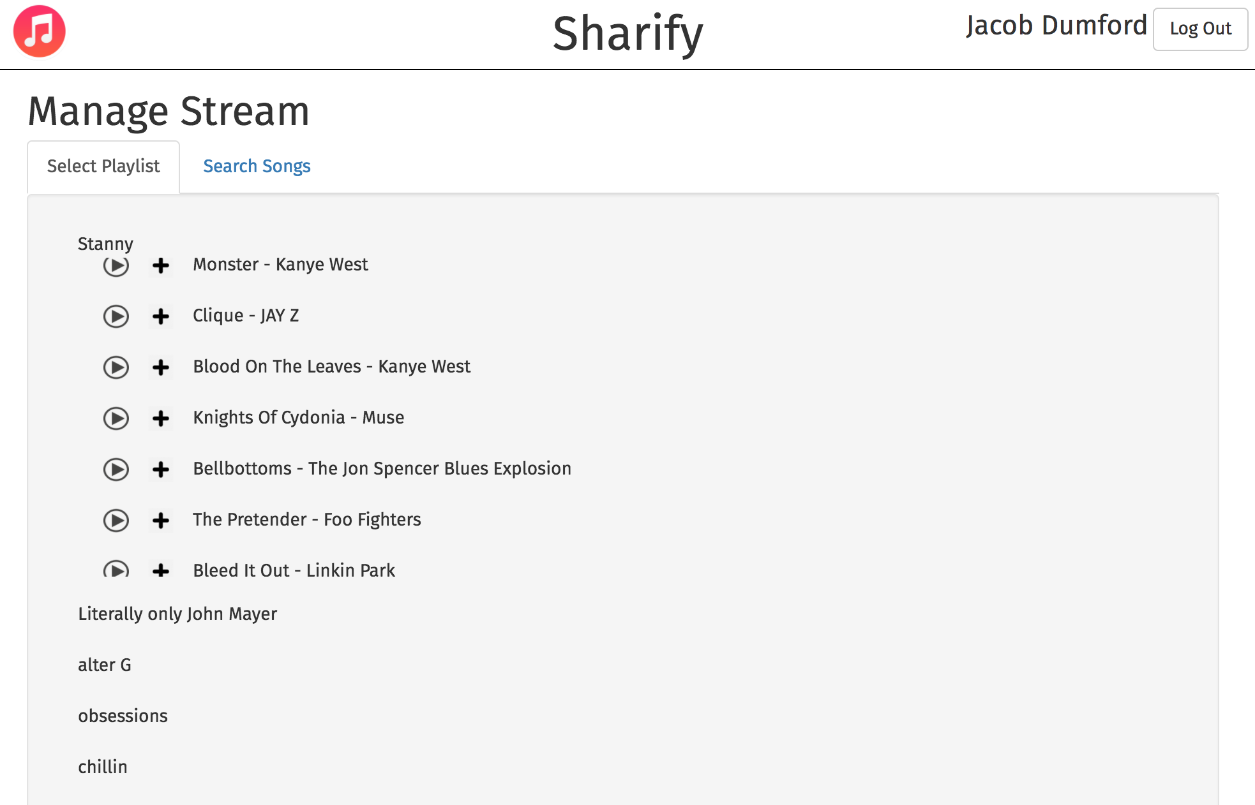

1. Search songs: In the search songs tab of the Manage Playlist section, you can type in the name of a song/artist/album and the first few results from Spotify will be shown.

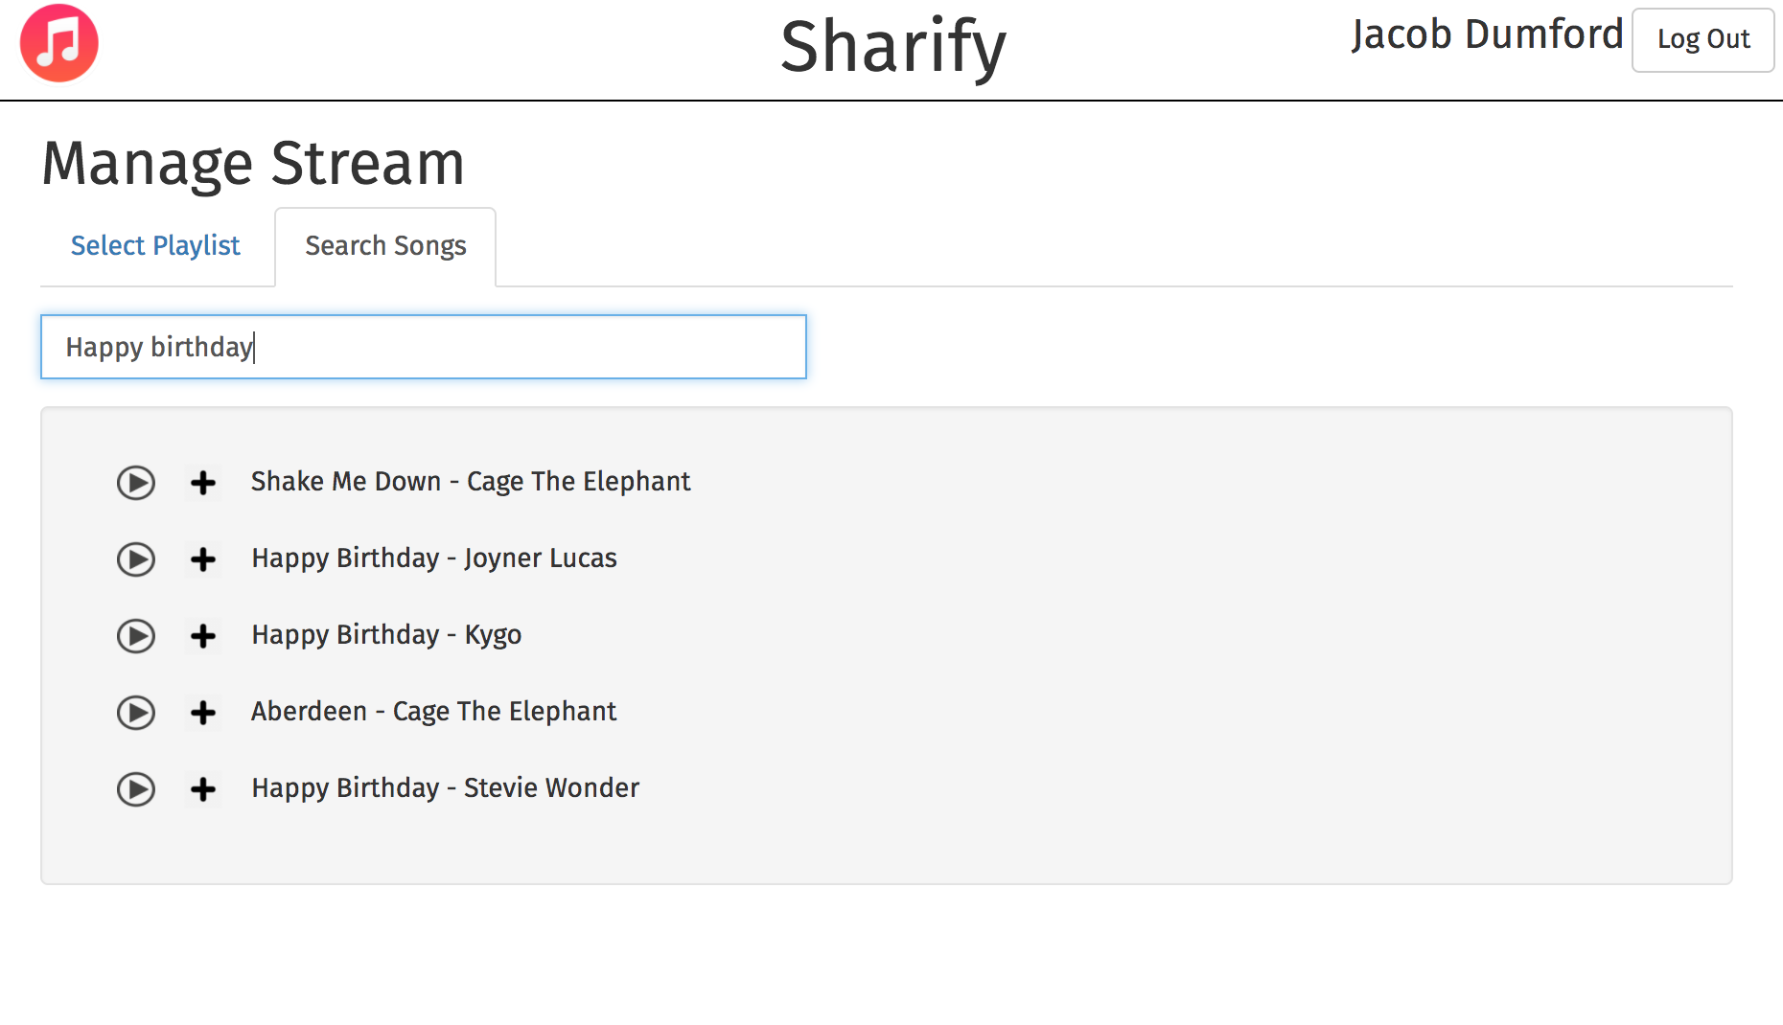

**Joining a Stream**

To join a stream, click on the play button on that stream. The song that streamer is listening to will start to play, and you will see the songs they have chosen appear in your queue.

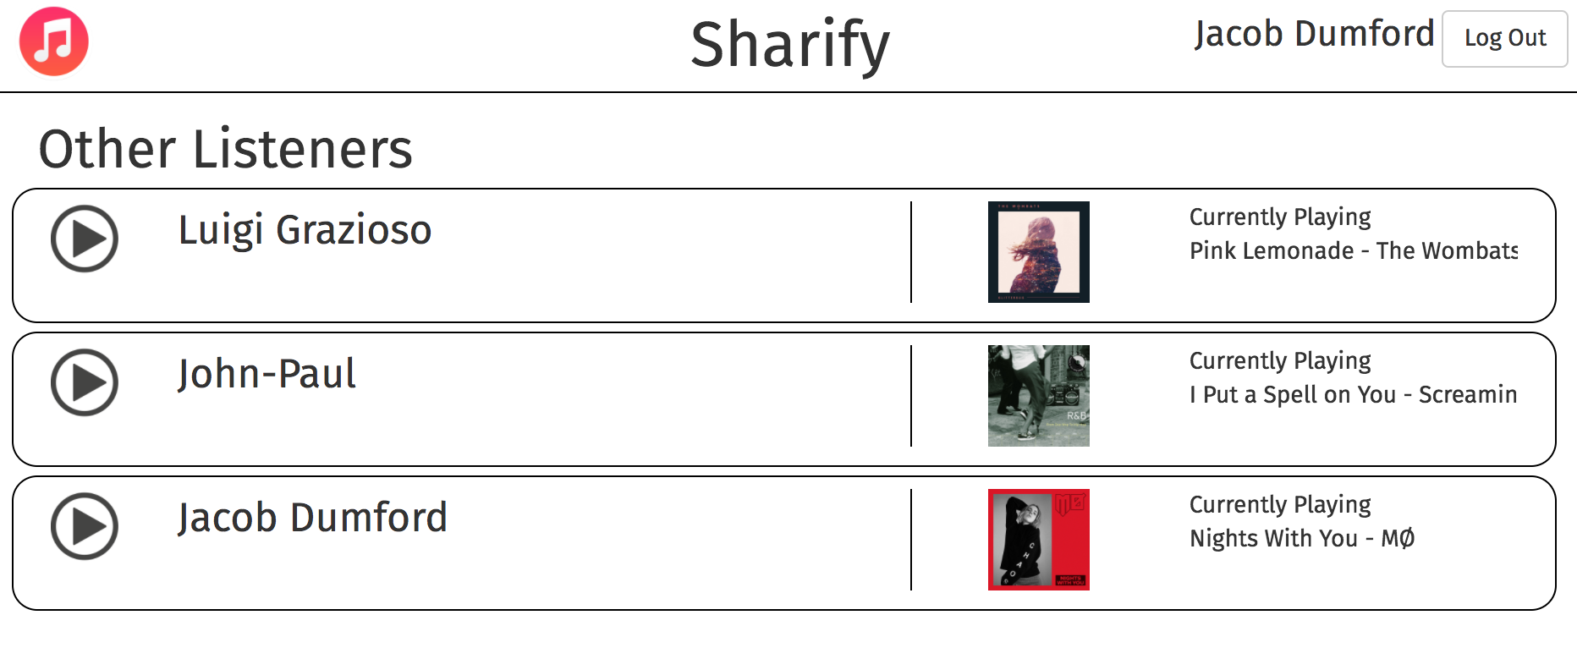

**Managing the Queue**

When browsing songs, use the plus button to add a song to the queue. It will appear at the bottom. Once a song has been added to the queue, any person (assuming the stream is collaborative) can upvote and downvote that song by clicking on the up arrow and down arrow. The queue will then be ordered by number of votes.

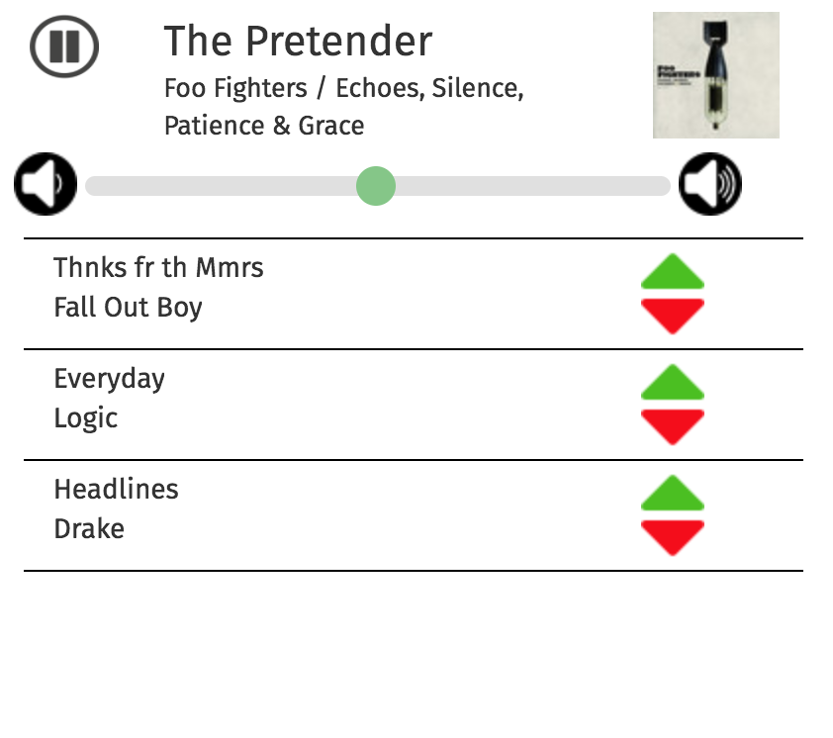

**Playing/Pausing Music**

To start playing a song, you may click the play button next to each song on the Manage Stream page. You can also click the play or pause button in the currently playing section on the top right of the screen.



**Adjusting Volume**

Use the slider in the currently playing section on the top right of the screen. Right for louder, left for quieter.



**Viewing User Profile**

To view your own profile, you may click your name on the top right of the screen. To view another person’s profile you may click their name on the stream in the main section.

